**T-SQL Homework 02c**

**Question 1**

List the date/time types in T-SQL.

DATETIME, SMALLDATETIME, DATE, TIME, DATETIME2, DATETIME OFFSET

**Question 2**

How do you express a date/time literal in T-SQL?

**Answer**

20200715

Select isdate(‘20200715’);

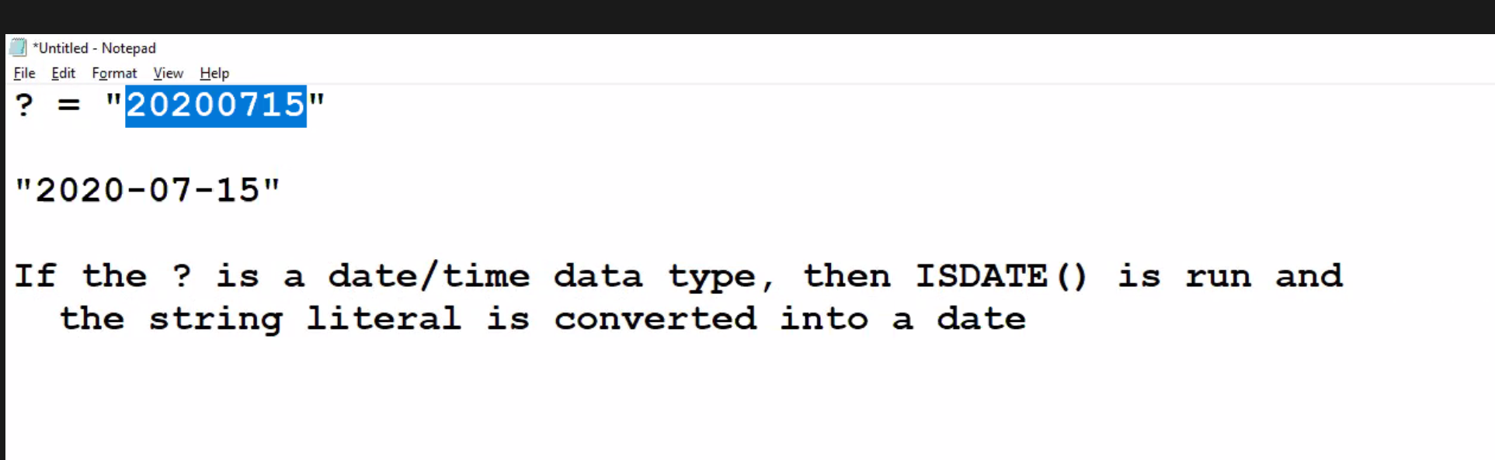

**Question 3**

What is the setting DATEFORMAT used for?

**Answer**

Sets the order of the month, day, and year date parts for interpreting date character string.

**Question 4**

Write a T-SQL snippet changing the date format to German. Read the documentation on how to do this.

**Answer**

DECLARE @thedate date = ‘2020-12-01’

SELECT FORMAT(@the date, ‘d’, ‘de-de’) Result;

DECLARE @thedate date = '2020-12-01'

SELECT FORMAT(@thedate, 'd', 'de-de') Result;

**Question 5**

What is the difference between CAST(), CONVERT(), and PARSE()?

**Answer**

The CAST method accepts just two parameters, expression, and target type, but CONVERT() also takes a third parameter representing the format of conversion, which is supported for some conversions, like between character strings and date-time values. PARSE() indicates the culture

**Question 6**

What function returns the current date? This is very useful in a table that maintains a log of events, such as user logins.

**Answer**

GETUTCDATE, SYSTEMDATETIME, CURRENTTIMESTAMP

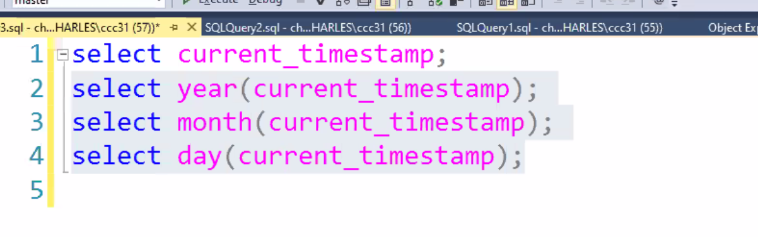

**Question 7**

How do you add one day to the current date? Add one week? Add one month? Add one year?

**Answer**

Use SWITCHOFFSET

**Question 8**

Write a SQL snippet to return the number of years between your birth date and today’s date?

**Answer**

Select julianday(“2020-07-15”) – julianday(“1998-04-14”) as tyras_age_in_days

Select (julianday(“2020-07-15”) – julianday(“1998-04-14”))*24*60*60 as tyras_age_in_days;

Second on is how old you are in seconds the first is in days.

Select datediff(year, ‘19980414’, ‘20200715’);

Give you how old you are in years

**Question 9**

How do you check a string literal to see if it represents a valid date?

**Answer**

Select isdate(‘enterdate’);

Returns one if it is a date returns zero if it is not a date

**Question 10**

What does EOMONTH() do? Give an example of why this might be very useful.

**Answer**

It returns the last day of the month of a specified date, with an optional offset.

**Question 11**

Payments are due exactly 30 days from the date of the last function. Write a select query that calculates the date of the next payment. Pretend we want to update a column in a database that contains the date of the next payment. We will do this when we write UPDATE queries.

**Answer**

k

**Question 12**

Suppose your son or daughter wants to run a query every day that tells them the number of days until their 16th birthday. Write a select query that does this.

**Answer**

k